**PROJECT : Stop Watch (GUI) IN JAVA**

**SUBJECT : OOP**

**ROLL NO : 24BSAI29,24BSAI07**

**SUBMITTED BY : Syed Muhammad Qasim,**

**Jawad Ali**

**SUBMITTED TO : Sir Sajjad**

Mehran University of Engineering and Technology Jamshoro

**OOP SEMESTER PROJECT**

|  |  |
| --- | --- |
| Roll No | : 24BSAI029,24BSAI07 |

### Project Title:

**Stopwatch Pro – A GUI-based Timer Application in Java**

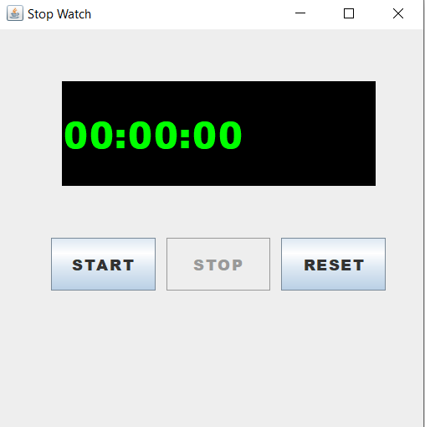

### 1. Introduction:

This is a simple stopwatch application created using Java Swing. It includes basic functionality like start, stop, and reset. The main goal was to practice GUI development and event handling in Java.

### 2. Tools Used:

* **Java**
* **Java Swing (for GUI)**
* **IDE: IntelliJ**

### 3. Project Overview:

* Stopwatch shows time in HH:MM:SS format.
* Three buttons:
  + **Start** – starts the timer.
  + **Stop** – pauses the timer.
  + **Reset** – resets timer to 00:00:00.

### 4. Main Features:

* Timer updates every second.
* Buttons are enabled/disabled based on current state.
* Clean and bold design with digital-style timer.

### 5. Code Summary:

* **StopWatch.java**: Creates buttons and label.
* **StopWatchPro.java**: Adds logic for timer and button actions.
* **Main.java**: Runs the app.

**Timer Running**

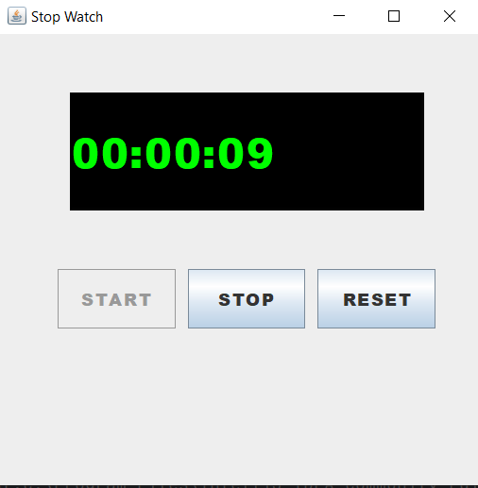

**Timer Stopped**

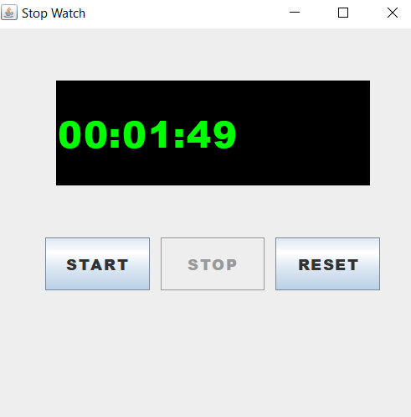

**After Reset**

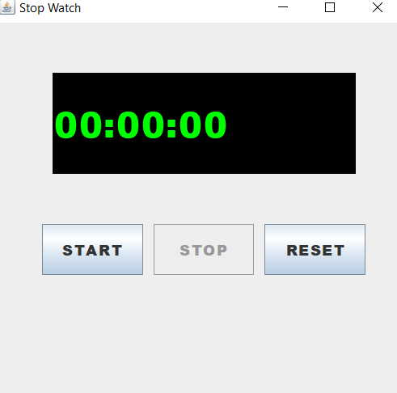

### 7. Conclusion:

This stopwatch app helped me understand GUI programming and OOP concepts in Java. It also improved my logic-building and design skills.